


Incident Response Report
<Client Full>

CONFIDENTIAL/PRIVILEGED



<IR2Y-XXXX>
<DD Month YYYY (date completed)>

Legal Acknowledgements
Copyright
©Copyright 2021 IBM Corporation. All Rights Reserved. This is unpublished material and contains confidential information and is subject to a confidentiality agreement. The unauthorized possession, use, reproduction, distribution, display, or disclosure of this material or the information contained herein is prohibited.
The methodologies and processes used in the conduct of this engagement are considered proprietary intellectual property of IBM and may not be disclosed without written permission from IBM. IBM authorizes you to copy this report for the purposes of disseminating information within your organization or any regulatory agency.
Confidentiality
This document contains confidential information of a proprietary and sensitive nature. As such this document should be afforded the security and handling precautions that a confidential document warrants. This document should have a controlled distribution to relevant parties only and should not be copied without written permission.
IBM treats the contents of any Emergency Response Services (IBM) engagement as confidential material and will not disclose the contents of this document to anyone without written permission.
Disclaimer
New technology, configuration changes, software upgrades and routine maintenance, among other items, can create new and unknown security exposures. Moreover, computer “hackers” and other third parties continue to employ increasingly sophisticated techniques and tools, resulting in ever-growing challenges to network and computer system security. The Report and the recommendations contained herein do not constitute any representation or warranty by IBM about the security of a company’s network and/or computer systems including, but not limited to, any representation that a company’s computer systems are safe from intrusions, viruses, or any other security exposures.
Document Control
Reviewers
Date | Current Version | Name
DD Month YYYY | Prepared by | <Main author>
DD Month YYYY | Reviewed by | <Senior consultant review>
DD Month YYYY | Approved by | <manager approval>

Change Record
Date | Version | Status-Description | Author
DD Month YYYY | 0.1 | Initial Draft | <Author>
DD Month YYYY | 0.2 | Initial Draft | <author>
DD Month YYYY | 1.0 | Final Draft | <author>

Table of Contents
1 Instruction on How to Use this Document 6
1.1 Structure of this Report 6
1.2 Report Writing Guidelines 7
1.3 Custom Document Properties 7
1.3.1 Populating Values 8
1.3.2 Updating References and Auto-Text 8
1.3.3 Using Custom Properties within the Content of the Document 9
1.4 Writing Recommendations 9
1.5 Other Hints on Using this Template 10
1.6 Release to the Client Checklist 10
2 Executive Summary 12
2.1 Background 12
2.2 Summary of XFIR Response and Analysis Conducted 13
2.3 Summary of Findings 13
2.4 Incident Timeline Summary 13
3 Background 14
3.1 Incident Declaration 14
3.2 Incident Details 14
3.3 Engagement 14
3.4 Limitations of the Investigation 14
4 Data Collection and Preservation 15
4.1 Evidence Sources 15
4.2 Data Acquisition 15
4.3 Property Disposition 16
5 Forensic Analysis and Findings 17
5.1 Summary of Findings 17
5.2 SystemOne 17
5.2.1 System Information 17
5.2.2 Event Logs 17
5.2.3 Windows Registry 18
5.2.4 Keyword Search 18
5.2.5 File System 18
5.3 System Two 18
5.4 System Three 18
5.5 Data Log Source(s) 19
5.6 Threat Hunting in EDR 19
6 Conclusions 20
7 Recommendations 21
7.1 <Recommendation 1> 21
7.2 <Recommendation 2> 21
7.3 <Recommendation 3> 21
7.4 <Recommendation 4> 21
Appendix A. Indicators of Compromise 22
A.1 File Based Indicators of Compromise 22
A.2 Network Based Indicators of Compromise 22
Appendix B. Compromised Accounts 23
Appendix C. Malware Analysis 24
Appendix D. List of Keywords Searched 25
Appendix E. Additional Documents 26

Instruction on How to Use this Document
MAKE SURE TO DELETE THIS CHAPTER BEFORE SENDING TO A CLIENT
Instructions on actions which need to be performed before sending Final Report to a Client are available in section 1.5 Other Hints on Using this Template

BEFORE YOU START WRITING REPORT
- Make sure to populate all or most of all the custom fields and update them in the report, BEFORE you start writing the content. It will remove the need to think what goes where.
- Make sure you have added Caption type for Code Listings into your local Word configuration. Instruction can be found on wiki: https://github.ibm.com/XFIR/XFIR-master-wiki/wiki/Documentation-and-Reporting-Style-Guide

Pre-baked Content and Supportive Comments
Ensure that the comments are visible, as these contain some guidance or examples for what must be changed within the report. To view the comments, set “Review” to “Simple Markup” from the drop down box and ensure that “Show Comments” button is enabled.
Report uses following colour marking schema:
- red text with yellow background – fragments which are already part of the pre-baked text of the report and require populating with values relevant to the case. You MUST change them. (Custom fields are not marked this way, as they will be automatically populated when you update document).
- black text with green background – fragments which are optional, being either examples or pre-baked text, which you may use as it is, modify or delete if it is not applicable to this engagement.
Make sure to review all content marked this way.

Sections Structure of this Report
This document has a pre-populated structure of the section and subsection, which should suit most of the engagements. Proposed structure follows best practices, and should not be generally changed unless you have a good reason to.
If you believe that structure template can be updated/improved, please provide feedback to IR Functional Lead.
- Executive Summary (literally is a summary of the facts in the report body, you cannot mention any new information in the Executive Summary that is not in the report body)
  - Background
  - Summary of X-Force IR Response and Analysis Conducted
  - Summary of Findings and Conclusions
  - Incident Timeline Summary (Only key notable observations, a full comprehensive timeline can be provided in an Appendix if needed)
- Background
  - Incident Declaration (When and by whom was the incident declared)
  - Incident Details (What is the background to the incident)
  - Engagement (What was the agreed scope of services)
  - Limitations of the Investigation (what prevented us from performing our scoped services or limited our results)
- Data Collection and Prevention
  - Evidence Sources (what was collected for analysis)
  - Data Acquisition (Who and how was the evidence collection performed)
  - Property Disposition (Who and how was/will the data securely disposed of)
- Forensic Analysis and Findings
  - Detailed results for systems and other evidence investigated (providing raw findings).
  - Additional sub section may be added to document other (not host-based) evidence sources, such as EDR based hunting, logs, etc.
- Summary of Findings and Conclusions
  - Do not include raw findings here, as they should have been presented in section 5 Forensic Analysis and Findings.
  - List what can be concluded from findings and performed investigation
- Recommendations (We have pre-written recommendations available to be pasted into the report within Resilient, see section 1.4 Writing Recommendations)
- Appendixes (Remove any not required for your report)
  - Indicators of Compromise
  - Compromised Accounts
  - Malware Analysis
  - List of Keywords Searched
  - Additional Documents

Report Writing Guidelines
Detailed guidelines on using styles, formatting and writing are documented on a XFIR Master Wiki: https://github.ibm.com/XFIR/XFIR-master-wiki/wiki/Documentation-and-Reporting-Style-Guide
Make sure you follow them while preparing this document! Not following guidelines may result in returning the report from Q&A for a correction!

Custom Document Properties
This document template utilises custom Word Document Properties to speed up pre-populating common words or phrases and to help minimise the chance of accidentally referring to the incorrect client. Available fields and their definition are documented in the below table. When value of the field is changed, a whole document can be easily updated and new value is populated in all places where field is used. When starting to build Final Report draft from this Template, make sure to populate as many of the fields as possible.
Field Name | Description
Client Full | The full name of the company/client, for example Acme Inc.
Client | The short name of the company/client, for example Acme. If there is no short name enter the same as used for Client Full.
XFIR ENGAGEMENT / CODENAME | IR2Y-XXXX, for example IR21-1234. This information will automatically be populated onto the cover page and into the footers.
CONFIDENTIAL/PRIVILEGED | This defaults to CONFIDENTIAL/PRIVILEGED, but might need to be changed. This field appears in the middle of the footer on each page.
Incident Initiator | This is the name of the person who made initial contact to report the incident. This information will automatically be populated into at least two places within the report.
Declaration Timestamp | This is the date and time when the incident initiator first contacted X-Force IR. The format must be DD Month YYYY at hh:mm. This information will automatically be populated into at least two places within the report.
Date Completed | This is the date that the report is submitted to the client. This will be populated on the cover page.
Engagement Date | This is the date that the client officially engaged XFIR to investigate the incident. This information will automatically be populated into at least two places within the report.

Populating Values
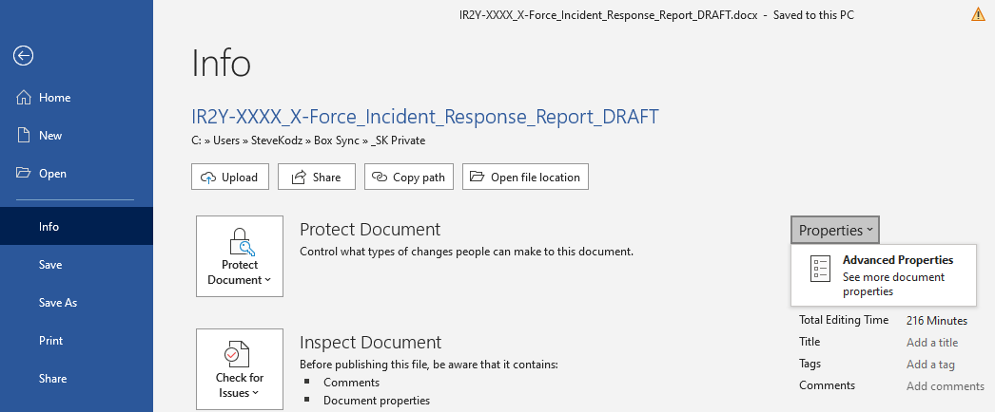
To edit the above properties, click on File, then select Info. Then click Properties and Advanced Properties, as shown below.

Once the Properties box opens go to the Custom tab and edit the fields by selecting them within the Properties section at the bottom and then editing the example text in the Value box. Once the text has been edited click the Modify button and select the next or click OK if done.

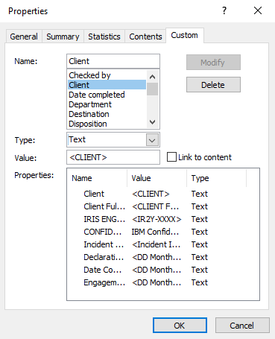
Updating References and Auto-Text
Once the document properties have been updated the document needs to be refreshed to apply the changes. Select the entire document by pressing CTRL+A and then press F9 to update all fields. You will be asked about updating the table of contents, select update entire table. Note: The footer will not be updated, therefore double click into the footer and repeat the CTRL+A and F9 sequence to update.
The document title is set by the Title document property and must be edited as a property, not on the cover page. If the title is changed, highlight it on the title page and press F9 to update.

Using Custom Properties within the Content of the Document
Custom document properties should be used also within the body of the report, whenever a value defined by the field is used. The most common situation are references to Client short name. Avoid typing Client name directly into the text – always use the field. Inserting the Client name as a field allows a report to be quickly anonymised. Note that other information may need to be anonymised as well.
Normally, to add a field into a text (eg. containing Client short name), you should click Insert -> Quick Parts -> Field, then highlight DocProperty and Client before clicking OK. The dialog box shown below shows the correct field information required.
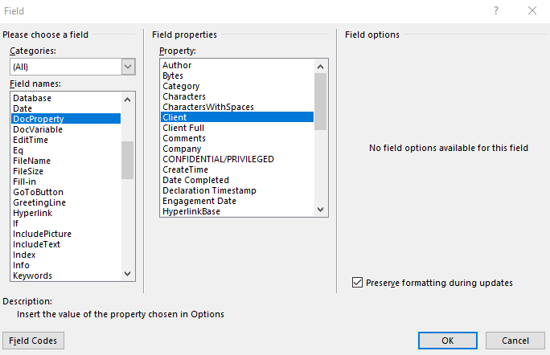

Because this is inconvenient and time consuming, an embedded macro has been added to this template. After pressing ‘CTRL+1’ the client’s short name as a field is added into a text. Because this functionality is provided as Macro, this document has docm extension and you need to enable macros. If you encounter any problems with this macro, please notify your IR Functional Lead, so the problem can be repaired in the template.

Preparing Recommendations
XFIR Remediation team prepared a pre-written set of recommendations, which should be sufficient for most of the cases. They are stored in “X-Force IRIS” Resilient instance, but in a separate “organisation” called “X-Force Remediation”. Reusing pre-written and pre-approved recommendations provides several benefits such as:
- Ensuring high quality - recommendations were written by a people having necessary expertise in a given area, while the IR/Forensics consultants working on the case may simply and naturally do not have this expertise.
- Saving time – just pull recommendations you need from Resilient, without a need to think what you need to write or search for previous report to copy and paste them. Also saves time during Q&A review process.
- Removing mistakes – by copying buggy recommendations from previous reports, replicating errors, missing some important recommendations because they have been forgotten
- Central management – allowing to quickly add new or update existing recommendations by Remediation team.
You report will be turned back by reviewer if you have not used pre-written recommendations.
Make sure that you always pull most recent version of recommendations from the Resilient and never copy paste them from previous reports. They may have been updated without your knowledge since you pulled them last time.
Instruction on how to export Recommendations is available on Remediation wiki:
https://github.ibm.com/XFIR/remediation-wiki/wiki/Resources

Other Hints on Using this Template
References to sections
Due to how styles are used in this document, when inserting reference, some sections may be not present on the list of headings, eg. appendixes. In such a case, switch “Reference type” to “Numbered item” and all sections should be available for using as reference.
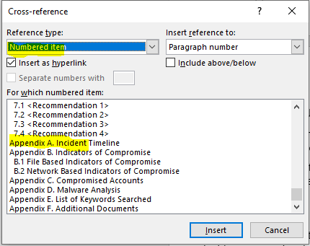

Report Approval Workflow
The report reviews and managerial approval flow must be followed for each deliverable and is documented here: https://github.ibm.com/XFIR/XFIR-master-wiki/wiki/Reporting-Guidelines-EMEA.

Release to the Client Checklist
Before you send this document to a client make sure to perform below actions:
- Remove DRAFT watermark:
  - Use “Design -> Watermark” from top Ribbon.
- Remove this chapter containing instructions:
  - The easiest way is to right click within “Navigation Pane” on the Top Heading “Instruction on How to Use This Document” and choose “Delete”.
- Update References and Auto-Text
  - follow instruction from Section 1.3.2 Updating References and Auto-Text
  - Remember to also update the footer in the same way
- Remove metadata containing Personal Information, before exporting this document to a PDF which is sent to a client. Instruction on how to do it is below.

Removing Personal Information metadata from document before exporting PDF
- Click “File -> Info-> Inspect Document”
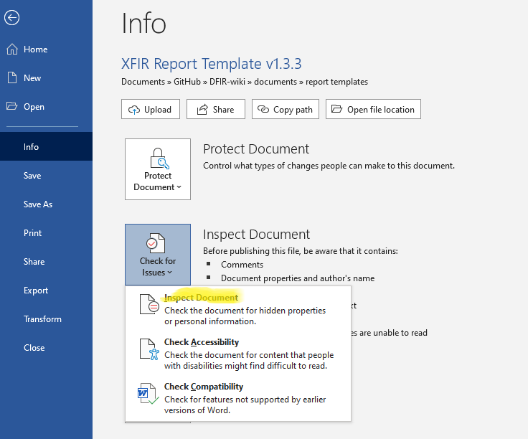
- Click Inspect:
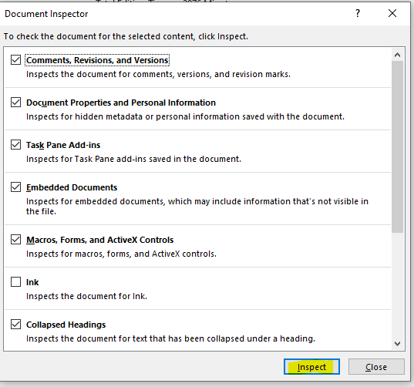
- Click ONLY “Remove All” for “Document Properties and Personal Information” and then “Close”.
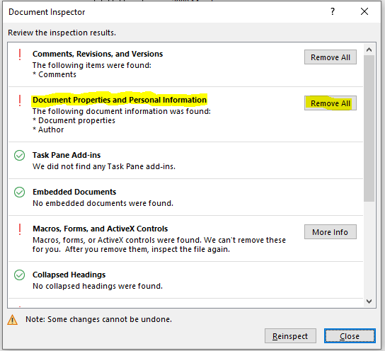
- Save as password protected PDF.

Executive Summary
This report presents findings and recommendations resulting from investigative activities performed by IBM Security X-Force Incident Response (‘XFIR’) on behalf of <Client Full> (‘<Client (short)>’).
Unless stated otherwise, all dates and times used in this report are in UTC time zone and presented within tables using modified ISO 8601 time format: YYYY-MM-DD hh:mm:ss.

Background
On <DD Month YYYY at hh:mm (declaration timestamp)>, <Incident Initiator> of <Client (short)> contacted XFIR to report a suspected incident concerning the <Client (short)> environment.
Following a triage call, that XFIR hosted on <DD Month YYYY at hh:mm>, XFIR’s understanding of the incident is <high level synopsis of circumstances (example in the comment)>.
On <DD Month YYYY (engagement date)>, <Client (short)> engaged XFIR to perform a forensic investigation with the following objectives:
- <objective 1>
- <objective 2>
- Determine if there is additional evidence originating from the <Client (short)> environment and if so, carry out necessary investigative activity in an effort to understand the scope of the compromise.
- Provide necessary containment and remediation recommendations to assist with resolving the potential incident.
- Provide recommendations on detecting future incidents and mitigating their impact to <Client (short)> business operations.
During the investigation, it was identified that <circumstances>, based upon this additional information the objectives of XFIR tasking was increased to include:
- <additional objective 1>
- <additional objective 2>
The initial in-scope timeframe for this investigation, as agreed with <Client (short)> is <DD Month YYYY to DD Month YYYY>. Based on the additional objectives, agreed on the <DD Month YYYY>, the in-scope timeframe was extended to <DD Month YYYY to DD Month YYYY>.

Summary of XFIR Response and Analysis Conducted
On <DD Month YYYY>, XFIR personnel attended site at <Client (short)> <offices/headquarters/location> in <location> and performed onsite incident response and investigative activities.
<OR>
XFIR’s activities were performed fully remotely with the <Client (short)> technical team providing access to digital evidence. This evidence was collected following guidance provided by XFIR.
XFIR established a cloud-based <EDR product> instance and deployed agents to <total> systems in the <Client (short)> environment.

XFIR performed forensic analysis of <total> forensic images, <total> memory images from compromised systems or systems of interest and <total size> of various logs.
XFIR worked in a close cooperation with <name eg. Kynrdyl> responsible for managing endpoints environment for <Client (short)>.

Summary of Findings
During the investigation, XFIR performed forensic analysis on historical log data and images of <Client (short)> systems provided for analysis. XFIR leveraged X-Force and 3rd party threat intelligence while incorporating analysis from various points of data and determined the following high-level points of significant malicious or suspicious activity. Based on the analysis performed, the findings can be summarised as follows:
- <finding 1>
- <finding 2>
- <address initial objectives from a client for this investigation>

Incident Timeline Summary
The timeline below provides a high-level overview of XFIR and notable activities as set out in the previous section, Summary of Findings and Conclusions.
Date/Time | Description
YYYY-MM-DD hh:mm:ss | Security researcher release a blog stating that a hard-coded password was identified within the application AV Manager for Windows. The blog location is ‘https://www.hacking-by-numbers.com/AV-Manager.html’.
YYYY-MM-DD hh:mm:ss | Malicious login to the ‘manager’ account from public IP address ‘123.45.67[.]89’.
YYYY-MM-DD hh:mm:ss
YYYY-MM-DD hh:mm:ss
Table 1 - High Level Summary of Important Events

Background
This section describes the background information concerning the performed investigation.

Incident Declaration
On <DD Month YYYY at hh:mm (declaration timestamp)>, <Incident Initiator> of <Client (short)> contacted XFIR to report a suspected incident concerning the <Client (short)> environment.

Incident Details
XFIR understands <high level synopsis of circumstances>.

Engagement
On <DD Month YYYY (engagement date)>, <Client (short)> engaged XFIR to perform a forensic investigation, the objectives of which were to:
- <objective 1>
- <objective 2>
- Determine if there is additional evidence originating from the <Client (short)> environment and if so, carry out necessary investigative activity in an effort to understand the scope of the compromise.
- Provide necessary containment and remediation recommendations to assist with resolving the potential incident.
- Provide recommendations on detecting future incidents and mitigating their impact to <Client (short)> business operations.
During the investigation, it was identified that <circumstances>, based upon this additional information the objectives of XFIR tasking was increased to include:
- <additional objective 1>
- <additional objective 2>

Limitations of the Investigation
The following aspects were limiting the scope and results of the XFIR investigation:
- Limitation 1.
- Limitation 2.

Data Collection and Preservation
During the investigation XFIR captured and took receipt of various evidence sources. Examination of this evidence was the foundation of the investigation in addition to various stakeholder interviews. During the investigation, XFIR performed forensic analysis on <number> forensic images acquired from systems related to the incident. XFIR and <Client (short)> personnel worked together to establish access and procedures for secure acquisition and transfer of the required data. Details of the evidence captured and/ or analysed is detailed in the sections which follow.

Evidence Sources
System images captured and/or analysed during this investigation are as follows:
Hostname | Type | Media ID | Image Name | MD5 Hash
JIMMY-WIN7 | Disk Image | <IR2Y-XXXX>_hostname | JIMMYC-WIN7.E01 | 756E088BD13AFAFB0106BA97CCC56545
BOB-WIN10 | Disk Image | <IR2Y-XXXX>_hostname | svaddc03_apr5_1-flat.vmdk | AFAE36608D2F76CAACC2D672F8D4DE43
SVADDC03 | Memory Image | <IR2Y-XXXX>_hostname_01 | SVADDC03-Snapshot55.vmem | D37CDC9F5CCD28F0B93EE37F88211F9B
Table 2 - Evidence Collected and Analysed
Log data captured and/or analysed during this investigation are as follows:
File Name | Description | MD5 Hash
somefilename.tar.gz | <type> logs from <device> for period YYYY-MM-DD to YYYY-MM-DD captured by XFIR. | 756E088BD13AFAFB0106BA97CCC56545
data.7z | <type> logs from <device> for period YYYY-MM-DD to YYYY-MM-DD provided by <customer>. | AFAE36608D2F76CAACC2D672F8D4DE43
Table 3 - Logs Collected and Analysed
Other evidence sources captured and/or analysed during this investigation are as follows:
File Name | Description | MD5 Hash
Golden Image | Golden Workstation Image | 756E088BD13AFAFB0106BA97CCC56545
Backup File | Backup of Domain Controller | AFAE36608D2F76CAACC2D672F8D4DE43
Table 4 - Other Evidence Sources Collected and Analysed

Data Acquisition
<detailed data acquisition information>
<describe the background to the data collected, its methods, and who performed what>

Property Disposition
The aforementioned evidence sources were collected and secured by XFIR <or> The aforementioned evidence sources were collected by <Client (short)> and secured by XFIR. Final disposition of all materials via IBM Property Control Document will be coordinated with <Client (short)> upon completion and acceptance of this written report.

Forensic Analysis and Findings
This section describes in detail the findings from each investigated system or evidence source. It contains results from full disk image analysis of systems listed in Evidence Sources as well as data extracted directly by XFIR from <EDR>, deployed for this investigation.
XFIR identified several malware samples and non-malicious tools used by the malicious actor. Since these were repeatedly used across multiple systems, XFIR analysis related to identified malware has been document in Appendix C Malware Analysis.
The following details the common analysis performed for each of the forensic disk images provided to XFIR:
- The internet browsing history was analysed for each system to identify possible signs of the initial infection vector.
- A review of files created or modified on, or around, the in-scope timeframe was undertaken within the filesystems, to identify malicious files existing or previously existing on each system.
- The Windows registry files were analysed to identify any further evidence of malicious activities.
- The Windows Event logs within each system were analysed to identify any suspicious activities related to logons, services, programs, and system operations around the in-scope period.
- McAfee anti-virus logs were analysed for any further signs of alerts relating to malware being created, deleted, or quarantined on the systems.
- Keyword searches for IoCs gathered from the analysis of the systems, along with known SilverFish IoCs identified by IBM Security X-Force Threat Intel were performed in an effort to discover further malicious activities.

SystemOne
<Explanation why this system was collected/investigated>

System Information
System Information
Version | Windows Server 2012 R2 Standard
Installed Date | 2020-04-17
Computer Name | XXXXXX
Last Shutdown | 2020-07-14
IP Address | 10.0.0[.]0
Table 5 - SystemOne – System Information

Event Logs
The Windows Event Logs from the system were analysed to identify any suspicious activities related to logons, services, program executions and system operations around the in-scope timeframe.
The available entries in the Windows Event Logs <partially | fully> covered the in-scope timeframe. The date ranges for the referenced and notable logs are listed below:
Windows Log Source | Start Date | End Date
Security | 2020-07-13 | 2020-07-14
System | 2020-04-27 | 2020-07-14
Microsoft-Windows-PowerShell Operational | 2020-04-17 | 2020-07-14
Table 6 - SystemOne – Log Information
The table below summarises the notable Windows events related to <describe shortly type of activity you are investigation>.
Date/Time | Account | Event ID | Description
2021-05-10 04:59:48 | myAccount | 21 | Successful RDP logon from ‘<IP Address/Workstation>’.
2021-05-10 04:59:48 | myAccount | 1149 | Successful RDP authentication from ‘<IP Address/Workstation>’.
2021-05-10 04:59:48 | myAccount | 4624 | Successful logon Type ‘<X>’ (Network/Interactive/RDP) from ‘<IP/Workstation>’. Session id ‘<XYZ>’.
2021-05-10 04:59:48 | myAccount | 4625 | Failed logon, reason: ‘<XYZ>’.
2021-05-10 04:59:48 | myAccount | 4634 | Successful logoff, session id ‘<XYZ>’.
2021-05-10 04:59:48 | myAccount | 4672 | Administrator privileges assigned, session id ‘<XYZ>’.
2021-05-10 04:59:48 | myAccount | 4688 | New process ‘<Path>’ created, as a child of ‘<Parent path>’.
2021-05-10 04:59:48 | myAccount | 4776 | <Successful/Failed> credentials validation by DC.
2021-05-10 04:59:48 | myAccount | 5140 | Network share ‘<share path>’ object accesses from ‘<IP address/workstation>’.
2021-05-10 04:59:48 | myAccount | 7045 | New service ‘<NAME>’ executing ‘<PATH TO EXE>’.
Table 6 - SystemOne – Notable Windows Event Logs
PROVIDE THE TEXTUAL INTERPRETATION OF THE ABOVE TABLE – WHAT DOES IT MEAN FOR A COLD READER

Windows Registry
The Windows Registry files from the system were analysed to identify any suspicious executions, installed programs or programs set to run automatically, which may have been created or modified around the in-scope timeframe. The notable events are presented in the below table.
Date/Time | Registry | Artifact | Description
2021-05-10 04:59:48 | SYSTEM | Shimache | First execution of ‘C:\malicious\binary.exe’.
2021-05-10 04:59:48 | SECURITY |  | Entry ‘XXX’ Added.
2021-05-10 04:59:48 | Amcache.hve |  | Execution of ‘C:\malicious\binary.exe’.
2021-05-10 04:59:48 | NTUSER.DAT for <ACCOUNT> | UserAssist | Last execution of ‘<Path to program>’, total count <X>.
2021-05-10 04:59:48 | NTUSER.DAT for <ACCOUNT> | TyperURLs | Typed ‘<Malicious URL>’ to <Browser>.
2021-05-10 04:59:48 | NTUSER.DAT for <ACCOUNT> | Shellbag | Last/First opened of ‘<PATH>’.
2021-05-10 04:59:48 | NTUSER.DAT for <ACCOUNT> | MRU | Opened ‘C:\Users\Public\Documents\Evil.doc’.
Table 6 - SystemOne – Notable Registry Based Findings
PROVIDE THE TEXTUAL INTERPRETATION OF THE ABOVE TABLE – WHAT DOES IT MEAN FOR A COLD READER
There were no further relevant findings observed within the provided evidence.
<OR if there were no findings at all>
There were no relevant findings observed within the provided evidence.

Keyword Search
XFIR performed keyword searches for several keywords to discover general command execution. A full list of keywords used for searching is available in Appendix D List of Keywords Searched.
There were no further relevant findings observed within the provided evidence.
<OR if there were no findings at all>
There were no relevant findings observed within the provided evidence.

File System Events
A review of files created or modified on or around the in-scope timeframe was undertaken. The notable events are presented in the table below.
Date/Time | Source File | Operation | Full Path
2021-05-10 04:59:48 | $MFT | Created | C:\Users\Public\Music\host.dll
2021-05-11 03:46:27 | C:\1.lnk | Modified | C:\Users\Public\1486r.exe
2021-05-11 03:48:50 | $MFT | Created ($FN) | C:\Users\Public\1063r.exe
Table 7 - SystemOne – Notable File System Events
PROVIDE THE TEXTUAL INTERPRETATION OF THE ABOVE TABLE – WHAT DOES IT MEAN FOR A COLD READER
There were no further relevant findings observed within the provided evidence.
<OR if there were no findings at all>
There were no relevant findings observed within the provided evidence.

Malware and Tools Used by Malicious Actor
Malware samples and tools used by the malicious actor, identified by XFIR during the course of investigation, are presented in the table below. Detailed technical analysis of analysed malware is available in Appendix C Malware Analysis.
Created Timestamp | Filename | File Path | SHA1 Hash
2021-05-10 04:59:48 | host.dll | C:\Users\Public\Music\ | A3560DA879904D44BDD76987C1E504F8
2021-05-11 03:46:27 | 1486r.exe | C:\Users\Public\ | C7F866C3476C0B047D4C583151A47CD4
2021-05-11 03:48:50 | 1063r.exe | C:\Users\Public\ | C7F866C3476C0B047D4C583151A47CD4
Table 7 - SystemOne –Malware Samples and Tools Used by Malicious Actor

System Two
OK
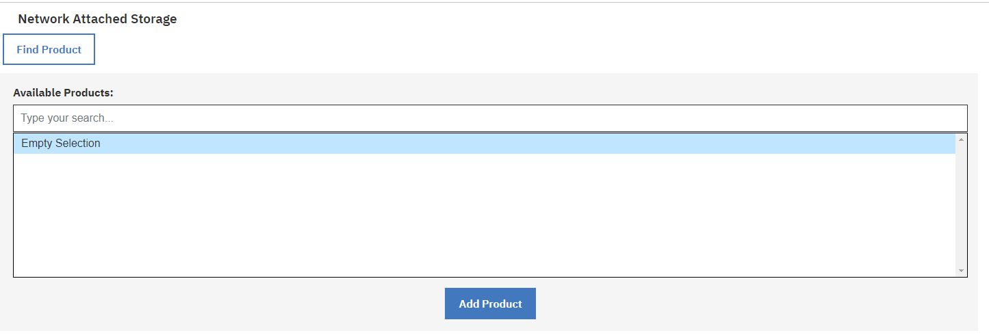
Figure 1 - Example of a Figure
Example of in-line code usage:
XFIR identified that the malicious actor ran the command .\mimikatz "privilege::debug" "sekurlsa::logonpasswords" exit from the directory 'C:\temp\mimikatz'.

#!/bin/bash
COUNTER=0
while [ $COUNTER -lt 10 ]; do
doevilstuff.sh
done
Code Listing 1 - Bash Script Added to 'crontab' File

System Three
OK

Data Log Source(s)
Placeholder for SIEM, Network logs etc. Update title depending on the needs or remove this section.

Threat Hunting in EDR
Placeholder - update title depending on the needs or remove this section.

Summary of Findings
The following section provides a summary of findings and highlights key XFIR insights from the performed investigation:
- <Insight 1>
- <Insight 2>
- <finding 1>
- <finding 2>
- <address initial objectives from a client for this investigation>

Recommendations
Based on observations during onsite and remote analysis, XFIR provides the recommendations below.
Many of these recommendations were implemented during the remediation effort of the investigation. As with any changes, these recommendations should be evaluated for applicability and overall effect to the operating environment.

<Recommendation Name>
Findings | <Populate based on findings from a case>
Control Description | <Populate from Remediation Resilient>
Implementation Reason | <Populate from Remediation Resilient>
Implementation Effort | <Populate from Remediation Resilient>
Control Framework Mapping | <Populate from Remediation Resilient>
References | <Populate from Remediation Resilient>

<Recommendation Name>
Findings | <Populate based on findings from a case>
Control Description | <Populate from Remediation Resilient>
Implementation Reason | <Populate from Remediation Resilient>
Implementation Effort | <Populate from Remediation Resilient>
Control Framework Mapping | <Populate from Remediation Resilient>
References | <Populate from Remediation Resilient>

- Indicators of Compromise
- File Based Indicators of Compromise
The table below contains all file based indicators of compromise identified during this investigation.
File Name | MD5 Hash | SHA1 Hash | Description
host.dll | A3560DA879904D44BDD76987C1E504F8 | A3560DA879904D44BDD76987C1E504F8 | Malicious service component.
1486r.exe | C7F866C3476C0B047D4C583151A47CD4 | A3560DA879904D44BDD76987C1E504F8 | Renamed Psexec.
1063r.exe | C7F866C3476C0B047D4C583151A47CD4 | A3560DA879904D44BDD76987C1E504F8
Table 8 - File Based Indicators of Compromise
- Network Based Indicators of Compromise
The table below contains all network based indicators of compromise identified during this investigation.
Domain/URL/IP Address | Description
104.21.29[.]42  172.67.148[.]93 | Command-and-control (C2) domain and resolved IP addresses.
207.102.109[.]106 | Source IP address connected to Citrix NetScaler.
Table 9 – Network Based Indicators of Compromise
- Compromised Accounts
The list below contains all accounts identified to have been compromised. XFIR generated this list during the incident investigation.
Account | Type of Account | Earliest Evidence of Compromise
MyServer/JamesDoe | Local administrator | 2021-05-03
CorpoDomain/RebecaDoe | Doman user | 2021-04-30
CorpoDomain/JoeDoe | Domain administrator | 2021-05-01
Table 10 - List of Compromised Account
- Malware Analysis
As provided by XFTI – make sure this uses the same template/formatting. Failure to submit the report with correct formatting will see it being returned for correction.
- List of Keywords Searched
The list below contains the keywords that have been used for searches throughout this investigation. Not all keywords will have been applied for each search.
- Keyword1
- Keyword2
- Keyword3
- Keyword4
Note that where IP addresses and URLs are listed in the above list, the performed searches did not use the square brackets which have been inserted throughout this report to prevent accidental connection to a potentially compromised destination.
- Additional Documents
The following documents will be included with this report and as such should be considered an important part of the report. They have been included separately for readability, size or otherwise being unsuitable to be included inline within this report.
File Name | Description | MD5 Hash
image1.png | Screenshot of malicious actor(s) opening files during a recorded remote support session. | A3560DA879904D44BDD76987C1E504F8
video1.mp4 | Complete recorded remote support session. | C7F866C3476C0B047D4C583151A47CD4
Table 11 – Files Supplied with the Report

© Copyright IBM Corporation 2022
IBM Security
Route 100
Somers, NY 10589
U.S.A.
Produced in the United States of America
January 2022
All Rights Reserved
IBM, the IBM logo, ibm.com, and IBM X-Force are trademarks or registered trademarks of International Business Machines Corporation in the United States, other countries, or both. If these and other IBM trademarked terms are marked on their first occurrence in this information with a trademark symbol (® or ™), these symbols indicate U.S. registered or common law trademarks owned by IBM at the time this information was published. Such trademarks may also be registered or common law trademarks in other countries. A current list of IBM trademarks is available on the Web at “Copyright and trademark information” at: ibm.com/legal/copytrade.shtml
Other product, company or service names may be trademarks or service marks of others.
References in this publication to IBM products or services do not
imply that IBM intends to make them available in all countries in which IBM operates.

